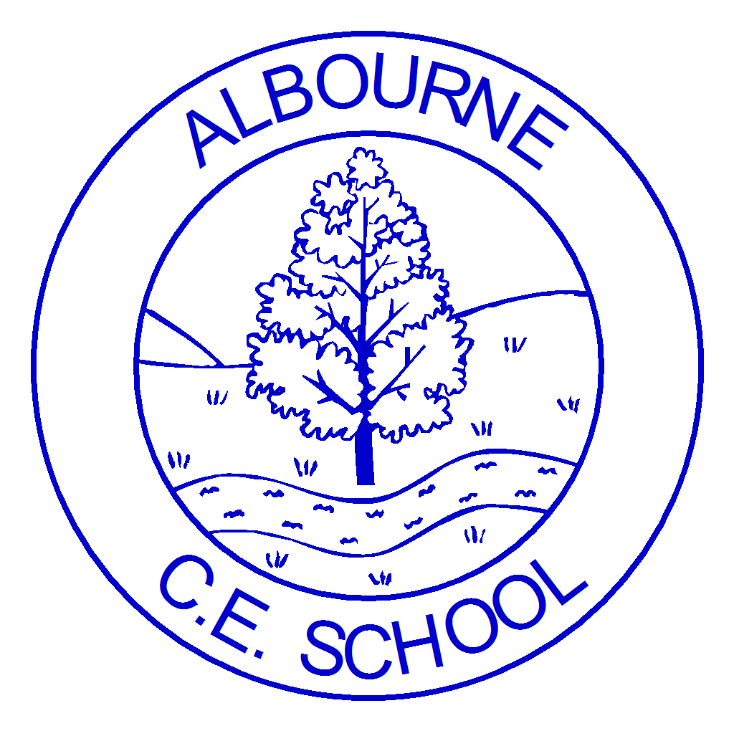
ALBOURNE PRIMARY SCHOOL
CURRICULUM MAP 2024-25
RECEPTION YEAR

Foundation Stage planning is used as a guide and not a “tick list”. This is to ensure that we have the flexibility to respond to individual needs, interests and cultures when appropriate.
 |  | Autumn Term |  | Spring Term |  | Summer Term
 |  | Autumn 1 | Autumn 2 | Spring 1 | Spring 2 | Summer 1 | Summer 2
 |  | All About Me  What makes me unique? | Toys!  How have toys changed over time? | Stomp, Chomp, Roar! (Dinosaurs)  What would we see if we could travel back in time? | Spring to Life  Why are eggs a symbol of Easter?
 |  |  |  |  | Once Upon a Time  What stories can you retell? | Under the Sea  Why are the oceans so important? | Mini-beasts  Why do we have bugs and what do they do?
Personal, Social and Emotional Development |  | Jigsaw Theme: Being Me in my World  What are my rights and responsibilities?  Help others to feel welcome.  Make our school community a better place.  Our right to learn.  Caring about everyone’s feelings.  Working well with others.  Following our learning charter. | Jigsaw Theme: Celebrating Difference  Everyone is different.  How can we celebrate difference? How can we include everyone? Know how to give and receive compliments. | Jigsaw Theme: Dreams and Goals  How can I achieve my dreams and goals?  Staying motivated through challenge.  Keep trying.  Working well with a partner.  Having a positive attitude.  Helping others to achieve their goals.  Working hard to achieve our goals. | Jigsaw Theme: Healthy Me  What makes me healthy, happy, and safe?  Healthy choices.  Balanced diet.  Physical activity.  Keeping ourselves and others safe.  Healthy relationships.  Keeping calm and dealing with difficulties. | Jigsaw Theme: Relationships  How can relationships affect me?  Making friends.  Solving friendship problems.  How to help others feel part of a group.  Respect in how we treat others.  What to do when you or someone feels upset/hurt.  Know/show what makes a good relationship. | Jigsaw Theme: Changing Me  What are our bodies like and how do they change?  Understanding that everyone is unique and special.  Expressing how you feel when change happens.  Understand change.  Understanding changes in others.  Asking for help.  Looking forward to change.
PSED LINKS TO  British Values |  | Democracy  Rule of Law  Individual Liberty  Mutual Respect  Tolerance of those with different faiths/beliefs | Democracy  Rule of Law  Individual Liberty  Mutual Respect  Tolerance of those with different faiths/beliefs | Democracy  Individual Liberty  Mutual Respect  Tolerance of those with different faiths/beliefs | Rule of Law  Individual Liberty  Mutual Respect  Tolerance of those with different faiths/beliefs | Democracy  Rule of Law  Individual Liberty  Mutual Respect  Tolerance of those with different faiths/beliefs | Individual Liberty  Mutual Respect  Tolerance of those with different faiths/beliefs
Physical Development incl. PE |  | Gross Motor Skills:  Revise fundamental movement skills including: rolling, crawling, walking, jumping, running  Lining up and queuing  PE: Multi-Skills | Gross Motor Skills:  Revise fundamental movement skills including: hopping, skipping, climbing  Develop overall body strength, co-ordination, balance, and agility – use wheeled resources to balance, sit or ride on, or push and pull.  Begin to use core muscle strength to achieve good posture when sitting at a table or on the floor  PE: Gymnastics | Gross Motor Skills:  Progress towards a more fluent style of moving, with developing control and co-ordination  Stop with precision and accuracy  Use core muscle strength to achieve good posture when sitting at a table or on the floor  Opportunities:  Wheeled toys, wheelbarrows, ropes to pull up, tunnels, tyres, structures, to jump on/off, den making materials  PE: Dance  Physical skills: lifting, carrying, pushing, pulling, constructing, stacking, and climbing. | Gross Motor Skills:  Combine different movements with ease and fluency  To spin, rock, tilt, fall, slide and bounce  Develop and refine a range of ball skills including: throwing, catching and kicking.  PE: Multi-Skills | Gross Motor Skills:  Children are challenged to go further with their physical activity, e.g., climbing higher, running faster etc  Develop and refine a range of ball skills including: passing, batting and aiming  PE: Multi-Skills | Gross Motor Skills:  Negotiate space and obstacles safely, with consideration for themselves and others.  Demonstrate strength, balance and coordination when playing  Develop confidence, competence, precision, and accuracy with ball activities  PE: Multi-Skills  Sports Day
Physical Development  (Fine Motor Focus) |  | Fine Motor Skills:  Pre- writing skills / fine motor strength  Upper arm and shoulder strength  Move and rotate their lower arms and wrists independently  Develop a pincer grip for writing  Opportunities: play dough, Lego, Sticklebricks, threading  Pouring, stirring, using spray bottles, dressing and undressing dolls and teddies  Pre writing shapes | Fine Motor Skills:  Use a range of tools competently, safely, and confidently  Begin to form recognisable letters  Opportunities: Practise free drawing, handwriting in RWI continued Funky Fingers activities | Fine Motor Skills:  Use correct tripod grip and forming increasing number of letters accurately  Activities: guided drawing/ copying to develop accuracy | Fine Motor Skills:  Use correct tripod grip and forming increasing number of letters accurately  Develop dexterity and strength for increased amounts of writing  Opportunities:  Weaving, sewing, cutting, puzzles | Fine Motor Skills:  Develop the foundations of a handwriting style which is fast, accurate and efficient.  Use a range of tools effectively, including paint brushes and cutlery  Show accuracy and care when drawing | Fine Motor Skills:  Develop the foundations of a handwriting style which is fast, accurate and efficient.  Use a range of tools effectively, including scissors and cutlery
C&L |  | Listening, Attention and Understanding:  Understand how to listen carefully and why it is important.  Respond to signals for listening.  Learn new vocabulary.  Answer questions.  Learn songs  Speaking:  Articulate ideas and thoughts in well-formed sentences.  Participate in one-to-one discussions  Develop social phrases | Listening, Attention and Understanding:  Ask questions to find out more  Listen to others, switching their attention as required  Learn and use new vocabulary  Speaking:  Connect one idea or action to another using a range of connectives.  Participate in class discussions | Listening, Attention and Understanding:  Ask questions to find out more and to check their understanding  Listen carefully to rhymes and songs, paying attention to how they sound.  Learn rhymes and songs  Speaking:  Describe events in detail  Listen to and talk about stories  Retell familiar stories | Listening, Attention and Understanding:  Use new vocabulary in different contexts  Participate in conversations, taking turns and adding relevant insights.  Speaking:  Retell stories and begin to create their own  Connect one idea or action to another using a range of connectives. Accurately use tenses  Use talk to help work out problems and organise their thinking | Listening, Attention and Understanding:  Learn rhymes, songs, and poems  Engage with non-fiction books  Listen attentively and respond to what they hear with relevant questions, comments and actions  Speaking:  Participate in small group and class discussions  Speak to different audiences, including their teachers, small groups and other school adults | Listening, Attention and Understanding:  Listen to and talk about non-fiction to develop a deep familiarity with new knowledge and vocabulary.  Hold conversation when engaged in back-and-forth exchanges with their teacher and peers  Speaking:  Offer explanations for why things might happen, making use of recently introduced vocabulary  Express their ideas and feelings about their experiences using full sentences, including use of past, present, and future tenses |  |  |  | Write recognisable letters, most of which are correctly formed.
Literacy |  | Key Texts:  - What Makes Me a Me  - Marvellous Me  - You Chose  - From Head to Toe  Supplementary Texts  - Super Duper You  - Only one you  - Love makes a family  - Elmer  - The Colour Monster  - All about families  - Starting school  - My world, your world | Key Texts:  - The Owl who was afraid of the Dark  - Peepo!  - Kipper’s Toy Box  - Old Bear  - Dear Santa  - Nativity story  Supplementary Texts  - Terrific toys  - Toys in space  - Lost in the toy museum  - Various non-fiction about toys | Key Texts:  - That’s not my dinosaur  - Dinosaur Lady  - Flip Flap  - Dear Dinosaur  - If I had a Dinosaur  - Tom and the Island of Dinosaurs  Supplementary Texts  - Harry and the bucketful of dinosaurs  - Tyrannosaurus Drip  - Non-fiction texts (dinosaurs and long ago) | Key Texts:  - Mr Wolf’s Pancakes  - Jack and the Beanstalk  - Luna New  - Luna New Year – The Great Race  - Little Red Hen  - The Very Hungry Caterpillar  - The Three Billy Goats Gruff  Supplementary Texts  - Jasper’s Beanstalk  - Oscar and the Frog  - The Gigantic Turnip  - Goldilocks & the Three Bears.  - One Little Butterfly  - The Tiny Seed  - The Odd Egg  (Varies depending on children’s interests and experiences) | Key Texts:  - Commotion in the Ocean  - Sea Creatures  - Here we are  - The whale who swallowed plastic  - Rainbow fish  Supplementary Texts  - Sharing a shell  - The Singing Mermaid  - The Snail and the Whale | Key Texts:  - Click , Clack, Moo: Cows that Type  - What the Ladybird Heard (Farm)  - Super worm  - Rosie’s Walk  - Yuck Worms  Supplementary Texts  - Sports Day  - Our New Teacher
 |  | Phonics:  - Read individual letters by saying the sounds for them.  - Begin to blend sounds into words, reading short words made up of known letter- sound correspondences  - RWI set 1 sounds  Reading group B | Phonics:  - Read individual letters by saying the sounds for them.  - Begin to blend sounds into words, reading short words made up of known letter- sound correspondences  - Read some letter groups that represent one sound (digraphs)  - RWI set 1 sounds  Reading group C | Phonics:  - Blend sounds into words, reading a range of words made up of known letter- sound correspondences  - Begin to read simple phrases and sentences made up of words with known letter- sound correspondences  - Begin to read ‘Red Words’ (tricky words)  Read Ditty level | Phonics:  - Continue to develop confidence when blending sounds to read words  - Read an increasing range of ‘Red Words’ (tricky words)  - Read simple phrases and sentences made up of words with known letter- sound correspondences  Read Red books | Phonics:  - Read simple phrases and sentences made up of words with known letter- sound correspondences  - Read a range of ‘Red Words’ with confidence  - Re-read phonetic books to build confidence and fluency  Read Green books | Phonics:  - Say a sound for each letter in the alphabet and at least 10 digraphs (ELG)  - Read words consistent with their phonic knowledge by sound-blending (ELG)  - Read simple sentences and some common exception words (ELG)  Read Green/ Purple books
 |  | Writing:  - To correctly hold a pencil using a tripod grip.  - Ascribe meaning to marks  - To write my name in lowercase letters. | Writing:  - To correctly hold a pencil using a tripod grip.  - To write my name in lowercase letters.  - To write initial sounds to label pictures.  - To write CVC words to label pictures using a sound mat.  - I put my finger under each word to check the sounds. | Writing:  - Think, say and remember a caption (2 or more words)  - To write a caption (A / The) | Writing:  - Think, say and remember a caption (2 or more words)  - To write a caption (A / The)  - To write CCVC / CVCC words (Set 2 sounds) using a sound mat.  - Leave spaces between words | Writing:  - Think, say, remember and write a simple sentence using the openers The, I, He and She.  - For example, I can see, I am, He is, She is, I saw, I went….  - I can spell my Red Words correctly (tricky words) * put, the, I, no, of, my, for, he (red) | Writing:  - Think, say, remember and write a simple sentence using the openers The, I, He and She.  - For example, I can see, I am, He is, She is, I saw, I went….  - Use a capital letter at the start of a sentence.  - Use a full stop at the end of a sentence.  - I put my finger under each word to read my sentence.  - I can spell my tricky words correctly * put, the, I, no, of, my, for, he (red books)  - your, said, you, be, are (green books)
Mathematics | Number and Numerical Patterns | - Identify when a set can be subitised and when counting is needed  - Subitise different arrangements, both unstructured and structured, including using the Hungarian number frame  - Make different arrangements of numbers within 5 and talk about what they can see, to develop their conceptual subitising skills  - Spot smaller numbers ‘hiding’ inside larger numbers  - Connect quantities and numbers to finger patterns and explore different ways of representing numbers on their fingers  - Hear and join in with the counting sequence, and connect this to the ‘staircase’ pattern of the counting numbers, seeing that each number is made of one more than the previous number  - Develop counting skills and knowledge, including: that the last number in the count tells us ‘how many’ (cardinality); to be accurate in counting, each thing must be counted once and once only and in any order; the need for 1:1 correspondence; understanding that anything can be counted, including actions and sounds  - Compare sets of objects by matching  - Begin to develop the language of ‘whole’ when talking about objects which have parts |  | - Continue to develop their subitising skills for numbers within and beyond 5, and increasingly connect quantities to numerals  - Begin to identify missing parts for numbers within 5  - Explore the structure of the numbers 6 and 7 as ‘5 and a bit’ and connect this to finger patterns and the Hungarian number frame  - Focus on equal and unequal groups when comparing numbers  - Understand that two equal groups can be called a ‘double’ and connect this to finger patterns  - Sort odd and even numbers according to their ‘shape’  - Continue to develop their understanding of the counting sequence and link cardinality and ordinality through the ‘staircase’ pattern  - Order numbers and play track games  - Join in with verbal counts beyond 20, hearing the repeated pattern within the counting numbers |  | - Continue to develop their counting skills, counting larger sets as well as counting actions and sounds  - Explore a range of representations of numbers, including the 10-frame, and see how doubles can be arranged in a 10-frame  - Compare quantities and numbers, including sets of objects which have different attributes  - Continue to develop a sense of magnitude, e.g. knowing that 8 is quite a lot more than 2, but 4 is only a little bit more than 2  - Begin to generalise about ‘one more than’ and ‘one less than’ numbers within 10  - Continue to identify when sets can be subitised and when counting is necessary  - Develop conceptual subitising skills including when using a rekenrek
Mathematics | Shape, Space and Measure | - Shape  - Understand and use the terms: straight, flat, curved, faces, solid, corner(s) (vertex/vertices) and edges whilst exploring shapes in the environment as well as using informal language.  - Identify and name common 2D shapes and discuss their properties (circle, triangle, square, and rectangle/oblong).  - Understand that sides relate to 2D shapes.  - Explain similarities and differences between shapes.  - Identify and name common 3D shapes (cube, cone, sphere, cuboid, cylinder and pyramid) and understand faces, edges and solid relate to 3D shapes and talk about their properties.  - Identify, copy and continue shape 2, 3 and 4 patterns; ABAB, ABCABC, ABCDABCD and AABBCCAABBC patterns. |  | - Spatial Reasoning:  - Create pictures using a range of 2D shapes. Explaining the choices made about how the shapes fit together.  - Copy 2D and 3D shape arrangements. Explain where the shapes are in relation to one another.  - Make 2D and 3D shape arrangements using a range of resources.  - Complete increasingly complex puzzles and shape puzzles ie tangrams and tessellating shapes to fit together.  - Combine shapes to make familiar shapes and name the new shapes made.  - Experimenting with shapes by flipping and turning objects in order to make shapes fit and create models; predicting and visualising how they will look.  - Make maps of familiar routes. |  | - Measure  - Measure and compare length and height using non –standard units  - Make direct comparisons and compare and order the length and width of 3 or more items from tallest/longest to shortest and narrowest to widest.  - Identify correctly the longest/tallest and shortest object in a set by lining objects up from the same starting point and comparing fairly.  - Use mathematical language to describe measuring length: long/longer/longest, short, shorter, shortest as I compare and order  the lengths of objects  - Use mathematical language to describe measuring height: tall/ taller, tallest and short, shorter, shortest when comparing and ordering the heights of objects.  - Weight  - Make direct comparisons, compare and order the weight of 3 or more objects from heaviest to lightest or lightest to heaviest.  - Use the terms heavy, heavier, heaviest and light, lighter, lightest when comparing and ordering the weights of objects.  - Understand that if the balance scale is level, the items being compared are equal in weight.  - Capacity and Volume  - Can use and describe the vocabulary terms for filling: full, nearly full, half full, nearly empty and empty when using volume.  - Can compare the volumes of 2 of the same containers that hold different amounts and use the terms more and less.  - Can order a set of 3 identical containers from least full to most full  - Time  - Use language to describe the passing of time by correctly using and understanding: before, after, today, yesterday and tomorrow  - Can sequence four or more familiar events and describe the sequence  - Can say the days of the week in the correct order.  - Experience measuring time with timers and calendars.
Understanding the World |  | Past and Present  - Talk about the lives of the people around them and their roles in society  - Talk about key events/ times in their lives  - Begin to organise events using basic chronology  (History)  People Culture and Community:  - Describe their immediate environment  - Draw information from a simple map  - Make their own simple maps of ‘their family’ ‘their heart’  - Explain some similarities and differences between life in this country and life in other countries  (linked to holidays and relatives and homes using ‘A Place Called Home’ )  (Geography) | Past and Present  - Know some similarities and differences between things in the past and now,  - Learn about the past through events, books, stories, characters  (History)  Toy loan boxes from Cuckfield Museum https://cuckfieldmuseum.org/loan-boxes/  Talk from parents about their toys from childhood  People Culture and Community:  - Recognise that people have different beliefs and celebrate special times in different ways.  - Understand that some places are special to members of their community  (RE) | Past and Present  - Understand the past through storytelling  - Compare and contrast characters from stories, including figures from the past  (History)  People Culture and Community:  - Look at maps in relation to Fairy Tales;  - Create their own maps  - Explain some similarities and differences between life in this country and life in other countries  (Geography) | Past and Present  People Culture and Community:  - Recognise that people have different beliefs and celebrate special times in different ways.  - Understand that some places and times are special to different communities  (RE)  (Easter) | Past and Present  - Understand the past through non-fiction texts  - Compare and contrast characters from stories, including figures from the past  (Mary Anning, Giddeon Mentel)  (History)  Dinosaur and Fossil loan box from Cuckfield Museum https://cuckfieldmuseum.org/loan-boxes/  People Culture and Community:  - Describe their immediate environment using knowledge from observation, (seaside trip) (Geography) | Past and Present  People Culture and Community:  - Explain some similarities and differences between life in this country and life in other countries -using maps  (Geography)
 |  | The Natural World:  - Make observations about the weather  - Describe what they see, hear and feel whilst outside  (Science) | The Natural World:  - What are the signs of Autumn?  - Describe what they see, hear and feel whilst outside  - (Science) | The Natural World:  - What are the signs of Winter?  - Describe what they see, hear and feel whilst outside  - Understand some important processes and changes in the natural world – fossilisation / evolution  (Science)  (Fossil loan box)  Welly Walks | The Natural World:  - What are the signs of Spring?  - Begin to make comparisons, noting similarities and differences between the seasons | The Natural World:  - Explore and explain life cycles  - Draw animals and plants from observation | The Natural World:  - Explore the natural world around them – make observations/ comparisons  Forest School at Hurst
RE |  | God/ Creation – why is the word ‘God’ so important to Christians? Harvest | Diwali  Incarnation – Why do Christians perform Nativity plays at Christmas?  Advent/ Nativity/ Christmas | Salvation – how can we help?  Luna New Year  Lent | Easter  Why do Christians put a cross in an Easter Garden? | Incarnation  What makes every single person unique and precious?  Ramadan | Creation  How can we care for our wonderful world?  EID
Expressive Art and Design |  | Creating with Materials:  - Explore and use a variety of artistic effects to express their ideas and feelings  - Use paint, pencil drawing, crayon, and loose parts to create self-portraits and family pictures  - Develop colour mixing skills  - Safely use paper, scissor, glue, and masking tape with purpose  (DT)  - Begin to share their creations and the processes they used  Paint themselves in their school uniform, draw their family, design their own Elmer  Explore faces – look at Picasso  Being Imaginative and Expressive:  See Music | Creating with Materials:  - Safely use and explore a variety of materials, tools and techniques, experimenting with colour, design, texture, form, and function  - Share their creations, explaining the process they have used;  Pastel drawing of toy, torn paper teddy, cup and ball toy (DT), junk model toy (DT)  Use clay to create a pot (Diwali) (DT)  Being Imaginative and Expressive:  See Music - Charanga  Singing daily songs: days of the week and familiar songs or poems before lunch | Creating with Materials:  - Safely use and explore a variety of materials, tools, and techniques.  - Make key design decisions relating to form and function  - Include different joins, flaps, levers etc  Whole class collage of dinosaur,  Observational drawings of fossils, junk model dinosaurs, silhouette and sunset mixed media pictures  Clay dinosaurs (DT)  Being Imaginative and Expressive:  See Music - Charanga  Singing daily songs: days of the week and familiar songs or poems before lunch | Creating with Materials:  - Make use of props and materials when role playing characters in narratives and stories  Retell a range of fairy tales, co-create a fairy tale role play area (cottage/ castle etc.),  Cook Pancakes (DT)  Being Imaginative and Expressive:  See Music - Charanga  Singing daily songs: days of the week and familiar songs or poems before lunch | Creating with Materials:  - Incorporate props and materials into role play, developing their own ideas and working collaboratively with others.  Retell and role play ‘The Rainbow Fish’, create a whole class, mixed media Rainbow fish, shell drawings, shell rubbings  Creating aquariums from paper plates (DT)  Being Imaginative and Expressive:  See Music – Charanga  Singing daily songs: days of the week and familiar songs or poems before lunch | Creating with Materials:  - Explore colour, texture and form  - Develop observational skills  - Revisit their work and decide upon any changes  - Explain the process they have taken and begin to explain why  Observational drawings, daffodils, bulbs, blossom etc  Using a range of media to create spring pictures  Split pin life cycles (DT)  Being Imaginative and Expressive:  See Music - Charanga  Singing daily songs: days of the week and familiar songs or poems before lunch
Music |  | Charanga Unit: Me!  - Begin to listen attentively, move to, and talk about music.  - Express their feelings and responses to music.  - Sing in a group. | Charanga Unit: My Stories  - Express their feelings and responses to music.  - Perform songs and stories with others.  - Begin to move in time with music.  - Engage in independent music making  Nativity | Charanga Unit: Everyone!  - Listen and respond to different styles of music  - Sing and learn to play instruments within a song  - Sing and perform songs, rhymes, poems and stories  - Begin to review and adapt their performances and consider their audience  - Invent, adapt, and recount narratives and stories with others | Charanga Unit: Our World  - Listen and respond to different styles of music.  - Begin to identify similarities and differences between different music styles  - Sing and learn to play instruments within a song  Links with UW – looking at life (including music and dance) in other countries | Charanga Unit: Big Bear Funk  - Continue to sing and listen to a range of songs  - Express their persona; responses to the music they hear  - Develop their ability to express their response to different styles of music.  - Begin to follow age-appropriate instructions to play collaborative music on instruments | Charanga Unit: Reflect, Rewind and Replay  - Continue to sing and listen to a range of songs  - Express their personal responses to the music they hear  - Further develop their ability to express their response to different styles of music.  - Develop their ability to follow age-appropriate instructions to play collaborative music on instruments
Trips, Visits and Experiences |  | - ‘All About Me’ Treasure Boxes  - Look at baby photos  - Harvest  - Local welly walks | - Toy Museum created in the hall, using topic loan boxes  - Harvest  - Local welly walks  - Nativity production  - Panto – rainbow theatre | - Local welly walks  - Theatre trip??  - Cuckfield Museum dinosaur artefacts and fossils | - World Book Day  - Local welly walks  - Traditional Tale Ball/ dress up day  - Divergent Drama Fairy Tale Workshop PTA?? | - Under the sea dress up day  - Local Welly Walks  - Frogspawn in the classroom | - Trip to Blackberry farm  - Local welly walks  - Caterpillars in classroom

